ASSIGNMENT 1

|  |  |
| --- | --- |
| ASSIGNMENT DATE | 24-SEP-2022 |
| STUDENT NAME | DINESHKUMAR M |
| STUDENT ROLL NUMBER | 2019104044 |
| MAXIMUM MARK | 2MARK |

QUESTION:

Build a smart home in tinker cad use atleast 2sensors,led,buzzer in a circuit. simulate in a single code.

SMART Home Circuit Connection:

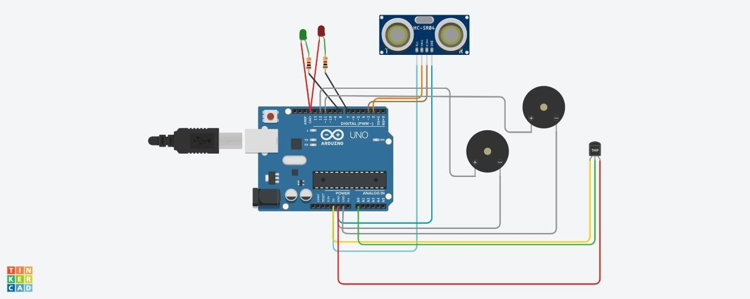

COMPONENTS

|  |  |
| --- | --- |
| Quantity | Component |
| 1 | Arduino Uno R3 |
| 1 | Red LED |
| 1 | Green LED |
| 1 | Temperature Sensor [TMP36] |
| 1 | Ultrasonic Distance Sensor |
| 2 | 1 kΩ Resistor |
| 2 | Piezo |